Supplementary material

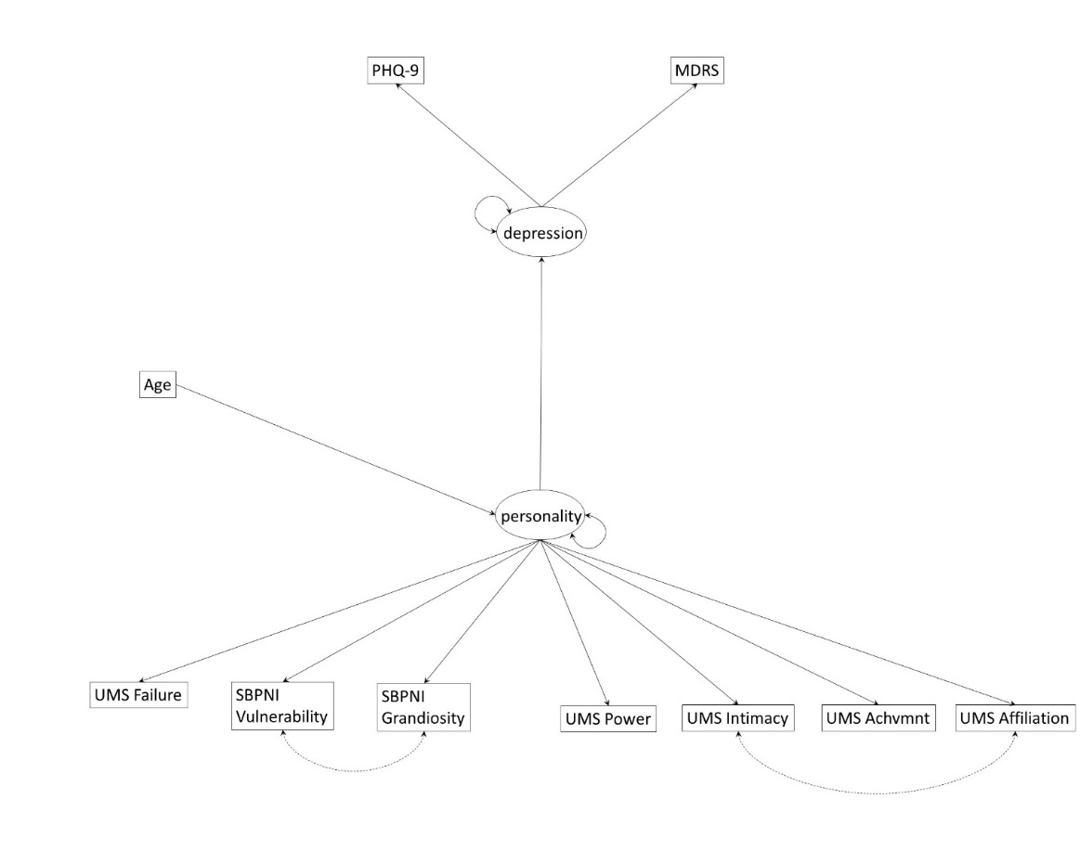

Supplementary Fig. 1. Alternative one-factor model. PHQ-9: Patient Health Questionnaire-Depression Module; MDRS: Male Depression Risk Scale; SBPNI: Super Brief Pathological Narcissism Inventory; UMS: Unified Motives Scale-3; Achvmnt: Achievement. Dashed line indicates added modification index to improve fit.

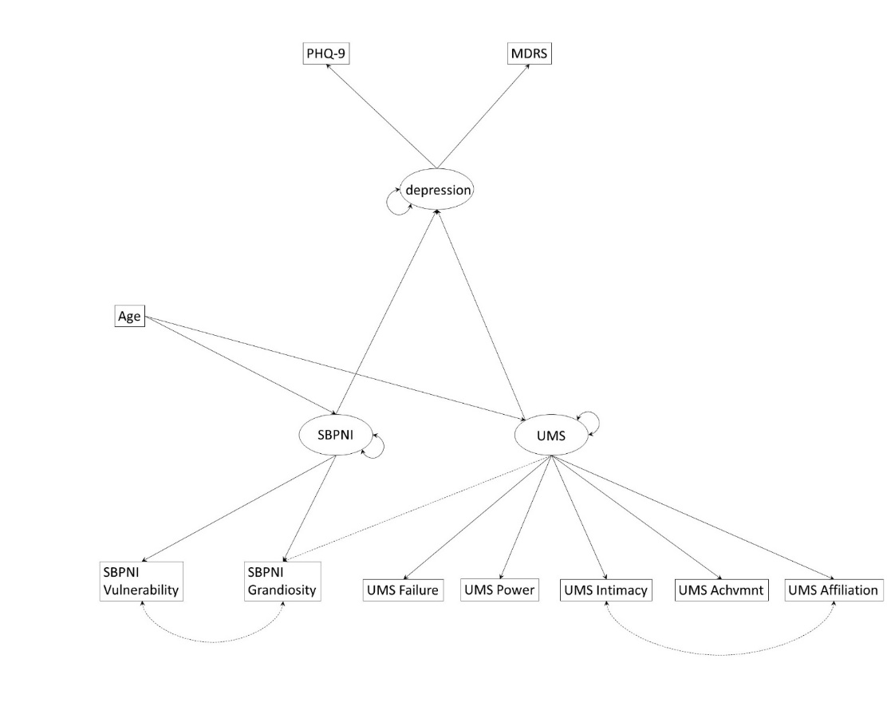

Supplementary Fig. 2. Alternative questionnaire-level model. PHQ-9: Patient Health Questionnaire-Depression Module; MDRS: Male Depression Risk Scale; SBPNI: Super Brief Pathological Narcissism Inventory; UMS: Unified Motives Scale-3; Achvmnt: Achievement. Dashed line indicates added modification index to improve fit.

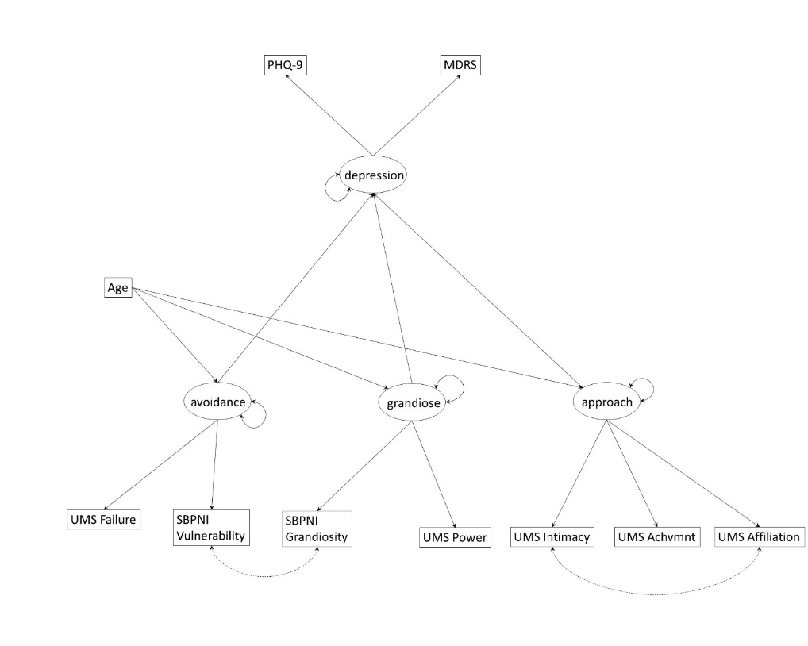

Supplementary Fig. 3. Alternative three-factor model. PHQ-9: Patient Health Questionnaire-Depression Module; MDRS: Male Depression Risk Scale; SBPNI: Super Brief Pathological Narcissism Inventory; UMS: Unified Motives Scale-3; Achvmnt: Achievement. Dashed line indicates added modification index to improve fit.